**User Story: Student can submit work report. (Iteration 1)**

Task: Write user documentation for submitting a form.

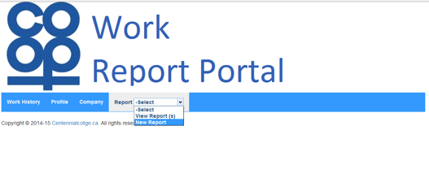The main idea behind the development of the system is that the coop student can easily submit their coop progress report online monthly so that they don’t have to undergo substantial amount of paper work at the end of the term. I order to submit coop progress report form, as a student you must be logged into the system and select new report tab from the dropdown menu in report tab (see figure 3). Once you select add new report option from the dropdown menu the system will be redirected you to monthly coop reporting form, wherein you have to fill out various information regarding the activities that you have performed in the month. Next, populating the form with required information you must hit the submit button to send the information; however, you may wish to choose cancel button to cancel the submission or later submission.

*Figure 3 CoopReporting application: student work report submission.*

After you successfully complete report submission the system will display message (see figure 4) regarding submission “Thank you for submitting you report”. This message will only displayed if you have successfully submitted your monthly coop report form. Further, you can verify your submission by viewing previous report under the dropdown menu (view reports see figure 5) of reports tab.

*Figure 4 CoopReporting application: report submission message display upon form submission.*

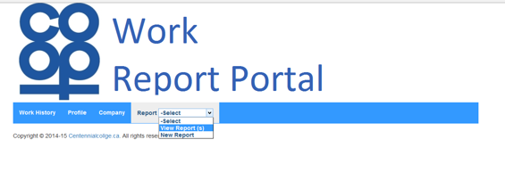

*Figure 5 CoopReporting application: view submitted report(s).*